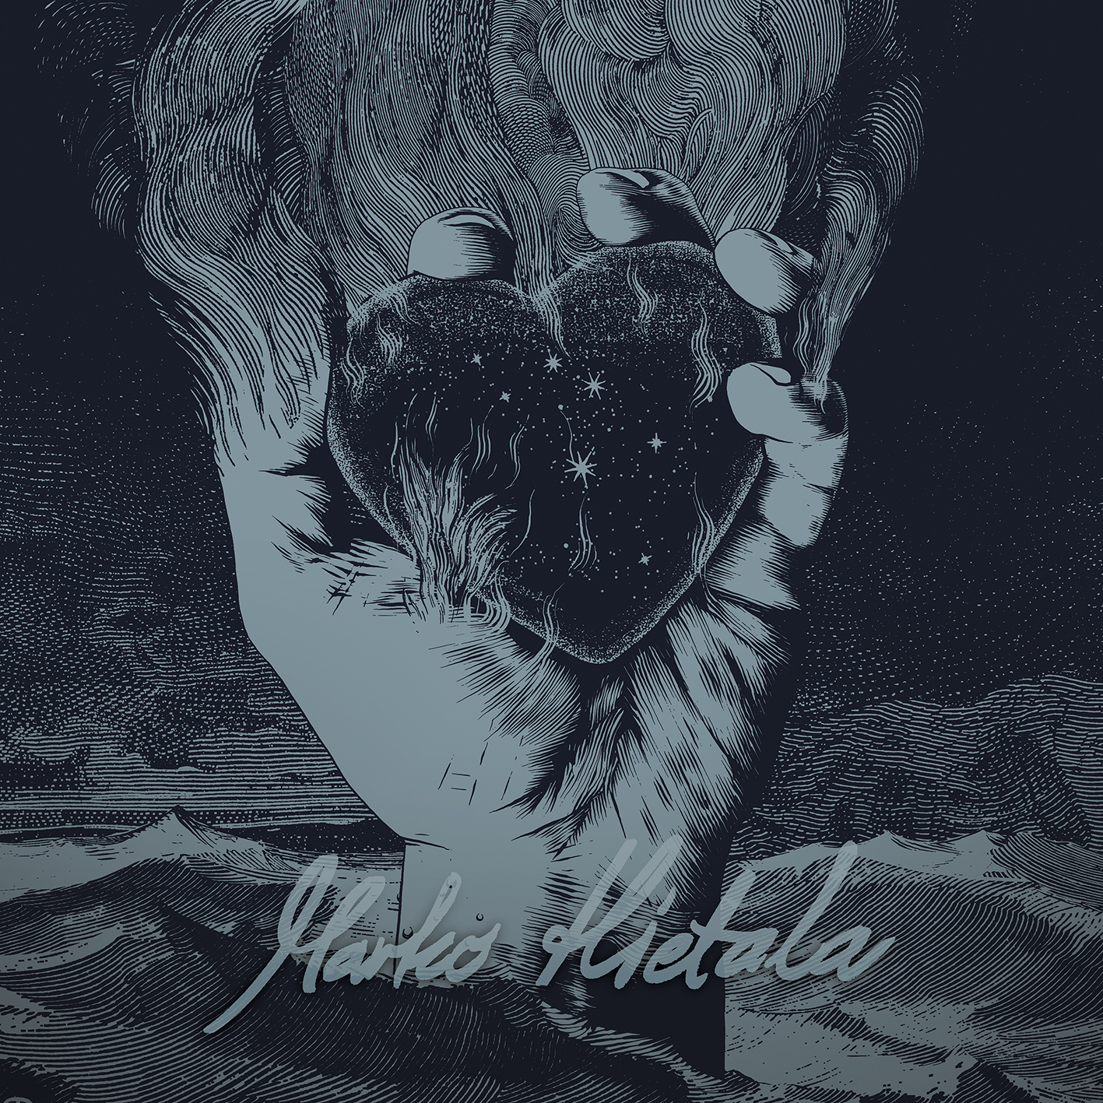

MARKO HIETALA
»Pyre Of The Black Heart«

OUT: January 24th, 2020
Line-Up:  Marko Hietala | Bass, Vocals  Tuomas Wäinölä | Guitar  Vili Ollila | Keyboards  Anssi Nykänen | Schlagzeug | MARKO HIETALA online:  www.facebook.com/markohietalaofficial/  www.nuclearblast.de/markohietala

After starting his influential career a few decades ago and selling countless copies of ground-breaking albums along the way, one might wonder what the next logical move is for one of the most gifted, singing heavy metal bassists of our (or all) time? Yes indeed: a solo record.

A solo studio album is exactly what Marko Hietala (you read it correctly, his long-term artist name has historically been Marco Hietala) has been working hard at for a very long time now. Yet the obvious question remains: why has it taken so damn long? With Marko’s unique kind of exceptional gift for playing, composing, singing and writing, many rock fans might have expected Marko Hietala's own studio recordings many, many moons ago.
Well, there has been some obstacles in the way of this – the most monumental of all of them being one certain Finnish musical ensemble named NIGHTWISH. When your band is hands down one of the biggest names in the world of heavy metal, there is plainly very little time for external activities.

Enter 2017, which also heralded NIGHTWISH's yearlong sabbatical, following their enormously successful "Endless Forms Most Beautiful" studio album and consequent 18-month long world tour.
"When we decided to allow some rest for NIGHTWISH – for the first time in about 20 years – I soon reached the point of realisation: ‘The time has come – I will be spending my year off working like hell... Working around my solo album’”, says Hietala with a smile. "My musical career started in the dawn of 1980s, and since then, I have been coming up with all kinds of ideas. Of course, a good pile of selected works have been used by NIGHTWISH and a huge number of epiphanies have been released via TAROT's – my other band‘s – albums, but besides these, there has been a lot of musical discoveries that have sounded a little more personal and also somewhat different... There is definitely a different kind of mind-set when you are just writing something out of the blue and there's simply zero need to justify any of these ideas to a band who already has its own style, sound and vision."

When asked about his certain goals concerning the first solo album – namely "Pyre Of The Black Heart" – Hietala ponders for a good moment. "Well, let's put it this way: NIGHTWISH is without any doubt my main band, and thanks to income from that direction, I don't have to be that commercially aware... What I mean is that when I was coming up with the musical thoughts for this solo record, I was able to do simply anything without limits. Really, even if I invented some completely wacky idea (that I liked), I just utilised it immediately without hesitation", laughs the bearded musician. "So if I had a goal, it was to not have any kind of limits, but to prepare an unpredictable, spontaneous, adventurous, ferocious and intimate solo record. And now when I am listening to the final album by myself, I can say with my hand on my heart that I – or rather us – pulled it off... The record is a really diverse musical roller coaster ride that takes eager listeners into a world of strong emotions and deep feelings!"

When a strong statement appears on the horizon, such as "Marko Hietala's going to release his first solo album", a lot of admirers of harder music might immediately jump to conclusions that there will be another "heavy metal to the bone" album in the pipeline. Well, think again. "I would describe the style of my solo record as "hard prog". There are definitely some rumbling metallic moments, but that's just one twist in a much bigger plot. Alongside powerful and heavy sounds, there are progressive flavours, acoustic moods, atmospheric stuff and whatnot", Hietala points out. "Just listen to the hard rocking first single "Stones" and accompany that with not-so-serious "Runner of the Railways" as well as epic and bombastic ballad "I Dream", and you have only scratched the surface. In other words: I have the courage to guarantee that there‘s so much different material to deal with!"

Hietala's voice has barely faded away, and he is already honouring his skillful band mates. "Even if "Pyre of the Black Heart" is definitely my solo album, I didn't compose everything on my own. When the song writing process was really in full swing, I kept sending all the ideas to my long-time collaborators Tuomas Wäinölä [guitar] and Vili Ollila [keyboards], and this ingenious two-some came up with great additions and arrangements, one after another. Drummer Anssi Nykänen – who is simply a wizard behind his set – completed the line-up like no other."

The already mentioned "time consumer" NIGHTWISH is soon re-starting its steaming motors with another studio album and world tour, but despite having this lurking on the horizon, Marko Hietala and his musical companions are heading out across European highways early next year. "Come February... We simply can't wait to get out on the road! It will be amazing to perform these solo songs for all those multinational friends of my music", Hietala nods and continues: "I strongly recommend coming out to see my band during this run, entitled "Tour of the Black Heart", as this will be my first and last European solo tour in a long time – or ever!"

